How to plot points.
Point.m

clear
px=[-2, 0, 3, 4] %Store x value for points.
py=[1, 2, 5, -2] % Store y value for points.
plot(px, py, '*') %Plot * sign on the points where (-2, 0), (0, 2), (3, 5), (4, -2).
axis([-4, 6, -4, 8]) %Decide x coordinate where from -4 to 6, and y coordinate where from -4 to 8.
grid on %Show grid.
box off %remove back lines of the coordinate’s plane.

How to draw a function.
Function.m

clear
syms x %Declare symbol x.
f(x)=sin(x) %Define a function.
fplot(f) %Plot the function f(x).
hold on
plot(-0.5, f(-0.5),’*’)
%If you want to restrict the domain.
fplot(f, [-2*pi, 2*pi],'r','LineWidth',3) %Plot the function f(x) where its domain is -2pi <= x <= 2pi. In Matlab, you cannot omit multiplication operator *.

How to draw an implicit curve.
ImplicitCurve.m

clear
syms x y %Declare symbols x and y.
F(x,y)=x^2+y^2-1 %Define an implicit function. The capital letter implies that the equation = 0, So this reveals a unit circle in implicit form.
fimplicit(F) %Draw implicit function F.
axis equal %Set axis equally.
%If you want to restrict the domain.
fimplicit(F,[0 2 0 2]) %The first two number in array is for x domain where 0<=x<=2, while the last two number show the domain of y where 0<=y<=2.
F(0,1) %On your command window, you can see ans=0, so point (0,1) is on the curve.

How to draw a surface(1).
surface1.m

clear
hold off
syms x y
f(x,y)=sin(x)+cos(y); %Define f(x,y), that is, z value based on x and y value, namely, we are defining a surface. FYI, if you write “F(x,y)” (I wrote “F” instead of “f”), this means F(x,y)=0 in Matlab. In this case you cannot draw a surface in 3D since z value is 0.
fsurf(f,[-10 10 -2 2]); %draw a surface f where -10<=x<=10, -2<=y<=2.
axis equal
xlabel('x') %put a label ‘x’ to x axis.
ylabel('y')
zlabel('z')
hold on
fimplicit(f,'r','Linewidth',3) %plot the implicit function defined by f(x,y)=0 over the default interval [-5 5] for x and y.

How to draw a surface(2).
surface2.m

clear
hold off
syms x y
f(x,y)=sin(x)+cos(y);
fsurf(f,'y'); %draw a surface f with yellow color.
axis equal
xlabel('x')
ylabel('y')
zlabel('z')
hold on
fimplicit(f,'r','Linewidth',3) %plot the implicit function defined by f(x,y)=0 over the default interval [-5 5] for x and y.
p=[2,3,f(2,3)]; %Define the point on the surface where x=2, y=3 and z=f(2,3).
plot3(p(1),p(2),p(3),'b*','MarkerSize',5) %Plot the point p with blue color and * character.

How to draw a surface (quarter sphere surface).
QuarterSphereSurface.m

clear
hold off
syms x y z
F(x,y,z)=x^2+y^2+z^2-1; %This means x^2+y^2+z^2-1 = 0 because of the capital letter “F”. When you define a function with a capital letter instead of a small letter, the function is equal to 0.
fimplicit3(F,[0 1])
axis equal
p=[2,1,2] %They are just set of numbers where p(1)==2, p(2)==1, p(3)==2. Remember, in this case, p(1) represents the 1st number of the array.
F(p(1),p(2),p(3))

How to draw a parametric curve with its tangent vector in 3D.
ParametrcCurve.m

clear
hold off
syms t
x(t)=t*cos(t);
y(t)=t*sin(t);
z(t)=t;
fplot3(x(t),y(t),z(t),[0 12*pi]) %when you draw a graph on 3D, use this, fplot3(x,y,z,[domain])
axis equal
xlabel('x') %make a label for x coordinate.
ylabel('y')
zlabel('z')
hold on
t0=6*pi; %set a parameter t0.
plot3(x(t0),y(t0),z(t0),'r*','MarkerSize',5) %when you plot a point in 3D, use plot3(x,y,z). ‘r*’ means plot * mark with red color. If you want to adjust the point’s size, use this, ‘MarkerSize’, size.
xd(t)=diff(x,t);
yd(t)=diff(y,t);
zd(t)=diff(z,t);
v=[xd(t0),yd(t0),zd(t0)];
p=[x(t0),y(t0),z(t0)];
quiver3(p(1),p(2),p(3),v(1),v(2),v(3),'r','LineWidth',2)

How to draw a torus with its tangent vector in 3D.
Torus.m
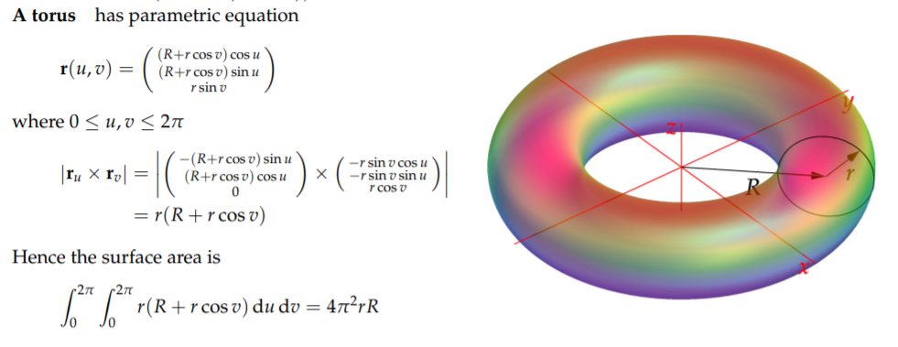

clear
hold off
syms u v
R=2; r=1; %Set R and r for a torus.
sx(u,v) = (R+r*cos(v))*cos(u); %Define a parametric torus. u and v are parameters.
sy(u,v) = (R+r*cos(v))*sin(u);
sz(u,v) = r*sin(v);
fsurf(sx,sy,sz, [0 2*pi 0 2*pi],'y') %Draw a surface of the parametric torus above.
axis equal

u0 = pi/2;
v0 = pi/4;
p=[sx(u0,v0),sy(u0,v0),sz(u0,v0)]; %Define a point p, which is on the surface of the torus.
hold on
plot3(p(1),p(2),p(3),'r*','MarkerSize',8) %Plot the point p.
cx(u)=sx(u,v0); %Define an isocurve c, with respect to u. v0 is the fixed (changed) parameter v. In other words, unknown is only u since v0=pi/4.
cy(u)=sy(u,v0);
cz(u)=sz(u,v0);
fplot3(cx,cy,cz,[0 2*pi],'b','LineWidth',3) %Plot the function above. [0 2*pi] is domain of u, from fsurf command we used above.
dx(v)=sx(u0,v); %Define an isocurve d, with respect to v. u0 is the fixed (changed) parameter u.
dy(v)=sy(u0,v);
dz(v)=sz(u0,v);
fplot3(dx,dy,dz,[0 2*pi],'m','LineWidth',3)

cxd=diff(cx,u); %Differentiate x of isocurve c at u parameter (since c is correspondence to u).
cyd=diff(cy,u); %Differentiate y of isocurve c at u parameter.
czd=diff(cz,u); %Differentiate z of isocurve c at u parameter.
cv=[cxd(u0),cyd(u0),czd(u0)]; %Define the tangent vector with respect to u.
quiver3(p(1),p(2),p(3),cv(1),cv(2),cv(3),'LineWidth',3) %Plot the tangent vector cv.

dxd(v)=diff(dx,v); %Differentiate x of isocurve d at v parameter (since d is correspondence to v).
dyd(v)=diff(dy,v); %Differentiate y of isocurve d at v parameter.
dzd(v)=diff(dz,v); %Differentiate z of isocurve d at v parameter.
dv=[dxd(v0),dyd(v0),dzd(v0)]; %Define the tangent vector with respect to v.
quiver3(p(1),p(2),p(3),dv(1),dv(2),dv(3),'LineWidth',3) %Plot the tangent vector dv.

normvec=cross(cv,dv); %Define the cross product (normal vector).
quiver3(p(1),p(2),p(3),normvec(1),normvec(2),normvec(3),'LineWidth',3) %Plot the cross product.

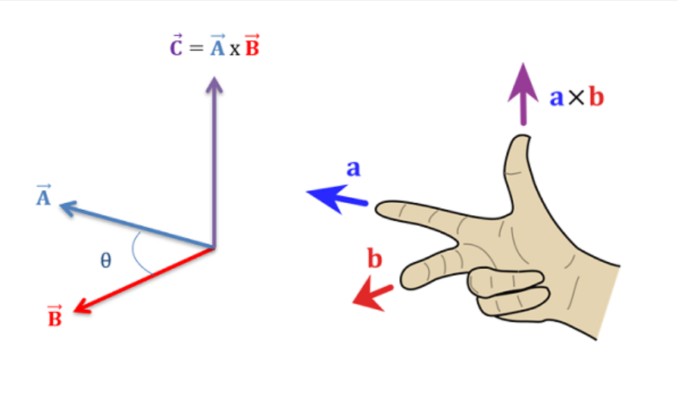

How to draw a parametric curve through 4 points in 2D.
Curve_P4.m

clear
hold off
px=[1,2,3,6]; %Define arbitrary x values.
py=[1,3,4,3]; %Define arbitrary y values.
plot(px,py,'b*'); %Plot 4 points {(1,1), (2,3), (3,4), (6,3)}.
axis equal; hold on;
t1=-1; t2=0; t3=1; t4=3; %Set parameters.
syms a3 a2 a1 a0 %Declare coefficients a3, a2, a1, a0 for the 3rd degree polynomial. (Why 3rd? Because a curve through 4 points is 3rd degree polynomial).
a3, a2, a1, a0 are unknown coefficients, but we can find the value of them by solving this simultaneous equation as you have learnt from high school.
ex=[a3*t1^3+a2*t1^2+a1*t1+a0==px(1),...
a3*t2^3+a2*t2^2+a1*t2+a0==px(2),...
a3*t3^3+a2*t3^2+a1*t3+a0==px(3),...
a3*t4^3+a2*t4^2+a1*t4+a0==px(4)
]; %Make simultaneous equation for x.
sx=solve(ex,[a3 a2 a1 a0]); %Semicolon ; is used to separate rows in an array creation command, or to suppress the output display of a line of code. If you want to see the calculation result on your command window, you need to delete the semicolon; .
syms t
x(t)=sx.a3*t^3+sx.a2*t^2+sx.a1*t+sx.a0 %Now we know the value of all coefficients, a3, a2, a1, a0, so we can create the equation which decides x value by parameter t for the parametric curve. sx.a3 means the result of a3 value by the equation sx.
syms b3 b2 b1 b0 %We will do the same thing for y value of the parametric curve.
ey=[b3*t1^3+b2*t1^2+b1*t1+b0==py(1),...
b3*t2^3+b2*t2^2+b1*t2+b0==py(2),...
b3*t3^3+b2*t3^2+b1*t3+b0==py(3),...
b3*t4^3+b2*t4^2+b1*t4+b0==py(4)
];
sy=solve(ey,[b3 b2 b1 b0]);
y(t)=sy.b3*t^3+sy.b2*t^2+sy.b1*t+sy.b0
fplot(x,y,[t1 t4],'r','LineWidth',2) %Plot the parametric function which goes through parameters t1, t2, t3, t4 in order.
In the previous topic, we have learnt how to draw a parametric curve in 2D, but it was a bit long code. There is more efficient way to draw it! Let‘s see how to do it!
Curve_2P2V.m

clear
px=[1, 6]; %Define x value for a point.
py=[1, 3]; %Define y value for a point. Now, we defined two points (1, 1), (6, 3) because we want the curve which trough from (1, 1) to (6, 3).
vx=[1, 3]; %Define x components for vectors.
vy=[3, -1]; %Define y components for vectors. Now, we defined (1, 3), (3, -1). We have two points and two vectors, which are enough information to define a curve!
plot(px,py,'b*'); %Plot two points according to px, py, {(1, 1), (6, 3)}.
axis equal; hold on; grid; %We need “hold on” since we want to plot a curve (another object) in the same screen. I added “grid” for better visualization.
quiver(px(1),py(1),vx(1),vy(1)); %px(1) denotes the first number of the array of px, in this case, px=[1, 6], so px(1) denotes 1.Similary, py(1)=1, vx=(1), vy=(3). This whole command line requests to draw the vector, its starting point is (px(1), py(1)), that is, (1, 1), and vector is (vx(1), vy(1)), namely (1, 3).
quiver(px(2),py(2),vx(2),vy(2)); %The starting point is (px(2), py(2)), that is, (6, 3), and vector is (vx(2), vy(2)), namely (1, -1).
syms a3 a2 a1 a0 t %Declare coefficients a3, a2, a1, a0 for the 3rd degree polynomial, and variable t.
x(t)=a3*t^3+a2*t^2+a1*t+a0; %A curve with multiple peaks & valley can be described by 3rd polynomial (by mathematical definition).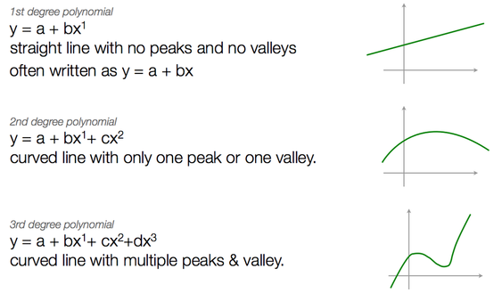
xd(t)=diff(x,t); %Differentiate x formula by t in order to obtain a tangent vector.
t1=0; t2=2; %Define parameters. Parameter represents “time”, let unit of time be second, then the curve goes through from t1 to t2 by (2-0) = 2 second.
ex = [x(t1)==px(1),... %We are defining the x value of point, px(1) is correspondence to the parameter t1. In other words, we are teaching a computer when parameter is t1, the x value of a point is px(1).
x(t2)==px(2),... %Similarly, we are defining another x value of point, px(2) is correspondence to the parameter t2.
xd(t1)==vx(1),... %We are saying that the derivative of x at parameter t1 equals the vector vx(1). Why? Because we want the curve which goes through two points from (1, 1) to (6, 3), and has vectors (1, 3), (3, -1) its starting points are (1, 1), (6, -3) respectively. Thus, the derivative of x at parameter t1 is namely the tangent vector, and we are trying to define the vector vx(1) will be equal to that tangent vector.
xd(t2)==vx(2)]; %Again, the derivative of x at parameter t2 is namely the tangent vector, and we are trying to define the vector vx(2) will be equal to that tangent vector.
sx=solve(ex, [a3 a2 a1 a0]) %Solve the simultaneous equation above. It is solvable since we have 4 unknown value, a3, a2, a1, a0, and 4 equations. Then, we know the value (solution) of a3, a2, a1, a0.
cx(t)=subs(x, [a3 a2 a1 a0], [sx.a3, sx.a2, sx.a1, sx.a0]) %Substitute the particular value of a3, a2, a1, a0 to the arbitrary a3, a2, a1, a0 of formula x(t) respectively. sx.a3 means the result of a3 value by the equation sx. This cx(t) is used only to determine the x value of the curve, hence if you plot this, the graph of cx(t) does not have meaning, our aim object is not this.
syms b3 b2 b1 b0 %We will do the same thing for y value of the curve which we are aiming.
y(t)=b3*t^3+b2*t^2+b1*t+b0;
yd(t)=diff(y,t);
ey = [y(t1)==py(1),...
y(t2)==py(2),...
yd(t1)==vy(1),...
yd(t2)==vy(2)];
sy=solve(ey, [b3 b2 b1 b0])
cy(t)=subs(y, [b3 b2 b1 b0], [sy.b3, sy.b2, sy.b1, sy.b0])
fplot(cx, cy, [t1 t2]) %Finally, we can plot the curve by using defined cx, cy and parameters. [t1 t2] means that the curve goes trough from t1 to t2.

How to draw a curve from 3 points and 1 vector.
Curve_3P1V.m
clear
hold off
px=[1, 3, 6];
py=[1, 5, 1.5]; %We got 3 points where (1, 1), (3, 5), (6, 1.5).
vx=[5];
vy=[0]; %We got a vector where (5, 0).
plot(px,py,'b*'); %Plot 3 points.
axis equal; hold on;
quiver(px(2),py(2),vx(1),vy(1)); %point (3,5) is defined as the starting point of vector (5,0).
syms a3 a2 a1 a0 t
x(t)=a3*t^3+a2*t^2+a1*t+a0; %3rd polynomial for a curve.
xd(t)=diff(x,t); %Differentiate x(t) formula by t.
t1=0; t2=1; t3=2; %Define parameters.
ex = [x(t1)==px(1),... %Define the x value of point, px(1) is correspondence to the parameter t1.
x(t2)==px(2),... %Similarly, we are defining another x value of point, px(2) is correspondence to the parameter t2.
x(t3)==px(3),... %Define another x value of point, px(3) is correspondence to the parameter t3.
xd(t2)==vx(1)]; %The derivative of x at parameter t2 is namely the tangent vector, and we are trying to define the vector vx(1) will be equal to that tangent vector.
sx=solve(ex, [a3 a2 a1 a0]) %Solve the simultaneous equation above.
cx(t)=subs(x, [a3 a2 a1 a0], [sx.a3, sx.a2, sx.a1, sx.a0])
syms b3 b2 b1 b0
y(t)=b3*t^3+b2*t^2+b1*t+b0;
yd(t)=diff(y,t);
ey = [y(t1)==py(1),...
y(t2)==py(2),...
y(t3)==py(3),...
yd(t2)==vy(1)];
sy=solve(ey, [b3 b2 b1 b0])
cy(t)=subs(y, [b3 b2 b1 b0], [sy.b3, sy.b2, sy.b1, sy.b0])
fplot(cx, cy, [t1 t3]) %Plot the target curve.

How to connect curves. To connect curves, we need to know the same point and tangent vector at last parameter for one curve, and the same point and tangent vector at first parameter for another curve, for connecting part of two curves.
Curve_2P2Vto2P2V.m

clear
px=[1, 6];
py=[1, 3];
vx=[1, 3];
vy=[3, -1];
plot(px,py,'b*');
axis equal; hold on;
quiver(px(1),py(1),vx(1),vy(1));
quiver(px(2),py(2),vx(2),vy(2));
syms a3 a2 a1 a0 t %To get the curve c(t), we need both x(t) and y(t). We will start with x(t) first.
x(t)=a3*t^3+a2*t^2+a1*t+a0;
xd(t)=diff(x,t);
t1=0; t2=2;
ex = [x(t1)==px(1),...
x(t2)==px(2),...
xd(t1)==vx(1),...
xd(t2)==vx(2)];
sx=solve(ex, [a3 a2 a1 a0])
cx(t)=subs(x, [a3 a2 a1 a0], [sx.a3, sx.a2, sx.a1, sx.a0])
syms b3 b2 b1 b0 %Do the same thing for y value of the curve.
y(t)=b3*t^3+b2*t^2+b1*t+b0;
yd(t)=diff(y,t);
ey = [y(t1)==py(1),...
y(t2)==py(2),...
yd(t1)==vy(1),...
yd(t2)==vy(2)];
sy=solve(ey, [b3 b2 b1 b0])
cy(t)=subs(y, [b3 b2 b1 b0], [sy.b3, sy.b2, sy.b1, sy.b0])
fplot(cx, cy, [t1 t2]) %At this point, we succeeded to draw the curve by 2 points and 2 vectors as input.
%Connect Hermite (connect the curve which we have got and another curve).
rx=[px(2),10];
ry=[py(2),5]; %Define two points where (px(2), py(2)), (10, 5). We need the same point for two different curves since we are trying to connect curves at the point (px(2), py(2)).
ux=[vx(2),0];
uy=[vy(2),5]; %Define two vectors where (vx(2), vy(2)), (0, 5). Similarly, we need the same vector for two different curves since we are trying to connect curves at the vector (vx(2), vy(2)).
plot(rx,ry,'*') %Plot two points where (6, 3), (10, 5).
quiver(rx(2), ry(2), ux(2), uy(2)); %Draw the vector (0, 5) while its starting point is (10, 5). To draw (or connect) curves, we need 1 more vector, but we already wrote “quiver(px(2),py(2),vx(2),vy(2))” before, which is not only the tangent vector for one curve but also for this connected curve so that they can be connected. Thus, we do not need to write it again.
t3=-1; t4=1; %Define parameters for the connected curve.
ex = [x(t3)==rx(1),...
x(t4)==rx(2),...
xd(t3)==ux(1),...
xd(t4)==ux(2)];
sx=solve(ex, [a3 a2 a1 a0])
dx(t)=subs(x, [a3 a2 a1 a0], [sx.a3, sx.a2, sx.a1, sx.a0])
ey = [y(t3)==ry(1),...
y(t4)==ry(2),...
yd(t3)==uy(1),...
yd(t4)==uy(2)];
sy=solve(ey, [b3 b2 b1 b0])
dy(t)=subs(y, [b3 b2 b1 b0], [sy.b3, sy.b2, sy.b1, sy.b0])
fplot(dx, dy, [t3 t4]) %Now you can plot this curve, and it is really connected to the curve which we already plot “fplot(cx, cy, [t1 t2])”.

